**Model CS-9014A**

**GPON ONU**

**(Optical Network Unit)**

Installation Guide Version 1.0

Copyrightⓒ CommScope Inc. All rights Reserved.

Without prior written approval of CommScope, any contents included in this document shall not be reproduced, copied, or partially extracted in any kind of format, including electrical, mechanical, and acoustical media, and in any other reason.

The information regarding the product in this guide is subject to change without notice for specific reasons.

The figures and information regarding the product in this guide may include some errata and printing errors. Those will be removed and corrected in the next revision version.

## Table of Contents

Table of Contents III

Introduction 1

Contents of the Package 1

Application of CS-9014A 1

Precautions 2

Appearance of unit 3

Front view 3

Rear view 4

Installation 5

Troubleshooting 7

## Introduction

CS-9014A is a GPON ONU that has optical video overlay function to enable the combined service delivery of RF video and IP Data in a single fiber environment. It supports 4-port Gigabit Ethernet interface, 1-port RF video overylay interface and 1 port GPON uplink over single optical fiber. It is designed as an indoor residential device and provides connectivity for internet, CATV and IP-based phone. The functionality of ONU is configured and managed by OLT through OMCI so that OLT monitors ONU status and manage QoS policy, alarm, and software upgrade.

CS-9014A features VLAN translation, VLAN trunking and VLAN tagging/untagging per Ethernet port which will give network operator the ability to construct network per its own requirements. Besides, the OAM features are based on standard compliant OMCI to facilitate more convenient and effective network operation.

### Contents of the Package

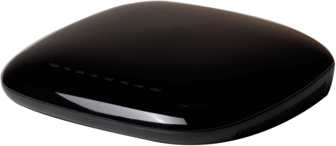

**Installation Guide**

**(optional)**

Installation Guide

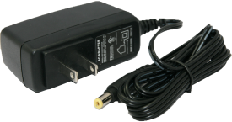

**RJ45 Cable**

**(optional)**

**Power Adaptor**

**CS-9014A**

### Application of CS-9014A

A typical network composition in actual use case where both data and video are addressed is depicted as below.

1550nm Tx

**Video**

1490nm Tx

1310nm Rx

1550nm/

1490nm

1310nm

Splitter

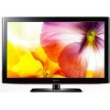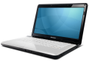

**CS-9014A**

EDFA

WDM

EPON OLT

OTX

**Data**

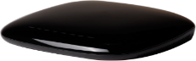

**CS-9014A**

TV

PC

PC

TV

## Precautions

|  |  |  |
| --- | --- | --- |
| 알림 및 경고 | **Warning** | Before you install the CS-9014A unit, read this section. Product installation should be conducted only by trained personel. |

#### Electrical safety

* Always use caution whenever handling live electrical material and contacts.
* Do not install electrical equipment in wet or damp conditions.
* Ensure that the power source for the unit is adequately rated to assure safe operation and provides current overload protection.
* Do not allow anything to be put on the power cable, and do not place this unit where people will stand or walk on the power cable.
* This unit should be used with the approved power adaptor which is included in the product package.

|  |  |  |
| --- | --- | --- |
| 알림 및 경고 | **Warning** | Do not open the enclosure without Comscope’s permission and technical support, which voids the warranty. |

#### Laser safety

* Use of controls or adjustments, or performance of procedures other than those specified herein may result in hazardous laser radiation exposure.
* To avoid exposure to radiation, do not stare into the aperture of a fiber-optic port. Invisible radiation might be emitted from the aperture of the port when no fiber cable is connected.
* Do not bend the optic fiber cables severely, which may damage the fiber or prevent the signal from being transmitted properly.
* Always keep unused fiber-optic ports capped with a clean dust cap.

|  |  |  |
| --- | --- | --- |
| 알림 및 경고 | **Warning** | Invisible laser radiation may be emitted from disconnected fibers or connectors. Never stare into beams or look directly to optical connectors. |

#### Preventing EMI

* When you run wires for any significant distance in an electromagnetic field, electro magnetic interference (EMI) can occur between the field and the signals on the wires.
* Bad plant wiring can result in radio frequency interference (RFI).
* If Strong EMI occurs in the installation place, consult RFI experts to get rid of it.

## Appearance of unit

CS-9014A is designed to have glossy black colored enclosure. In front area of the unit is the array of LEDs meanwhile the rear area has the ports for Ethernet, RF and PON connectivity and jack for power adaptor.

### Front view

The meaning of each LEDs are summarized in [Table 1].

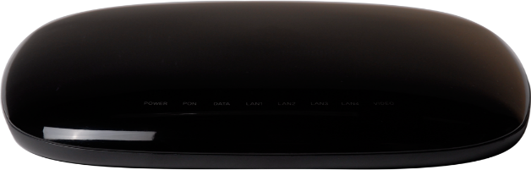

Array of LEDs

#### [Table 1] LED operation and its meaning

|  |  |  |  |  |
| --- | --- | --- | --- | --- |
| **Name** | **Color** | **Status** | **Function** | **Actions to take** |
| PWR | BLUE | ON | Power ON |  |
| OFF | Power OFF | Check to connect Power adapter & power outlet |
| PON | BLUE | ON | Link Up (Normal) | Normal Operation |
| BLINK  (Every 1 sec) | Link Down. Optic signal ON | Call Service Provider |
| RED | ON | Optical signal has been lost | Call Service Provider |
| DATA | BLUE | OFF | No Data Transmitting/Receiving | Call Service Provider |
| BLINK | Transmitting/Receiving Data | Normal Operation |
| LAN 1~4 | BLUE | ON | 1000Base-T Ethernet Link Up | Normal Operation |
| BLINK | 1000Base-T Transmitting/Receiving Ethernet data | Normal Operation |
| OFF | Link Down | Check Connection with PCs |
| RED | ON | 100Base-TX Ethernet Link Up | Normal Operation |
| BLINK | 100Base-TX Transmitting/Receiving Ethernet data | Normal Operation |
| OFF | Link Down | Check Connection with PCs |
| VIDEO | BLUE | ON | VIDEO Signal Receiving | Normal Operation |
| RED | ON | RF Optic Power Error | Call Service Provider |
| OFF | No VIDEO Signal | Call Service Provider |

### Rear view

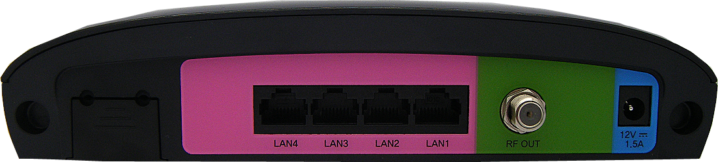

[Table 2] Describes the ports of CS-9014A ONU.

#### [Table 2] Ports and jack on rear panel

|  |  |
| --- | --- |
| **Indication** | **Description** |
|  | GPON Port where the optic fiber from OLT is connected. |
| LAN 1~4 | Gigabit Ethernet Ports where RJ-45 Category-5 UTP cable is connected. |
| RF OUT | RF Video Port where coaxial F-connector is connected. |
| 1.2VDC21.5 A | Power Terminal where Power adapter tap is connected. |

## Installation

CS-9014A is a bridge type ONU. Once it is connected with cables and power adapter in appropriate manner it will operate automatically. It does not require any particular setup procedure over dedicated web access. The criteria to determine whether installation has been completed properly or not is LED operation.

The sequence of installation is described from step 1 to 4 as below:

1. Connect the SC/APC connector on one end of a single-mode optical fiber into the optical terminal of the optical outlet (it could be a splitter or PIU card of an OLT) and the other end into the PON port of CS-9014A - #1 in the figure - by pushing it utill a click sound is heard.
2. Connect any LAN port of CS-9014A - #2 in the figure – and a PC with an Ethernet cable which has RJ-45 plug head. Up to 4 PC or its equivalent (e.g. IP phone) can be accommodated.
3. Connect the CS-9014A coax port - #3 in the figure – and a television with a 75 ohm Coaxial cable which has F-connectors.
4. Connect the rated power adaptor (12V 1.5A) provided together with CS-9014A to the power jack in the unit - #4 in the figure.



**[Figure 1] Ports and jack at rear panel**

The following steps can be referenced to see if the unit is in normal status when all the necessary connection for the unit is completed.

* Make sure that the POWER LED is ON.

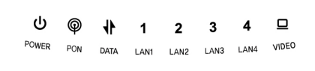

* Make sure that LAN LED is ON according to [Table 1].



* Make sure that the PON LED is ON in several seconds or minutes. If PON LED is red, the optical signal is very low, so please contact your service provider.
* If everything is installed properly, the user can see the DATA LED blink while Internet data is sent / received.



* If you connect coaxial F-connector to RF OUT port for CATV, the user can see the VIDEO LED lit blue while video data is being received.

## Troubleshooting

A couple of possible trouble and its quick remedy:

**Symptom 1: “Can not access to the Internet” -**

**Step 1** Make sure that the ONU is turned on. Once you turn on the power, the POWER LED on the front panel of CS-9014A should be lit. If the POWER LED is not lit, please check if the power cable is connected to the power inlet of ONU properly. If the problem persists, please call Service Provider.

**Step 2** Makesure that the optical line is connected properly. Once the optic fiber is connected, the PON LED on the front panel of CS-9014A should be lit on within few seconds. If the PON LED blinks, call Service Provider to check the optical line connection.

**Step 3** Make sure that the LAN cable is connected properly. Once the LAN cable is connected and user PC is turned on, LAN LED should be lit on. If the LED is not lit, check the cable connection.

**Step 4** Make sure that network setting of your PC is correct. Select “set to ‘Obtain IP address automatically’.

**Symptom 2: “All the cables are connected, but still can not obtain IP address”**

**Step 1** Look for the Network Neighborhood or My Network Places icon in your PC. If it is not there, try your Start Menu.

**Step 2** Right-click the Network Neighborhood/My Network Places icon. A drop-down menu will appear.

**Step 3** Choose the "Properties" option, which is generally found at the bottom of the menu.

**Step 4** Look for an icon named "Local Area Connection". The icon looks like a pair of computer connected by a link. Double-click this icon.

**Step 5** Click the "General" tab, if it is not already selected. You will see a list of protocols to choose.

**Step 6** Scroll down and choose Internet Protocol (TCP/IP), and then click the button that is labeled "Properties".

**Step 7** Again, click the "General" tab, it is not already selected. You will see two choices:

1. "Obtain an IP address Automatically"
2. "Use the following IP address..."

**Step 8** Choose option “1)”

**Step 9** Click OK